1.Summary of problem statement, data and findings

Every good abstract describes briefly what was intended at the outset, and summarizes findings and implications.

The problem was to correctly assign a ticket to the respective incident resolution team, such that the incident can be addressed optimally with the minimal amount of interruption for the end user at the least possible cost for the IT incident management team.

A NLP classifier can be used for analysing the text which is given in the ticket and then correctly assign the ticket to the respective incident resolution team.

The data consisted of four columns as given below:

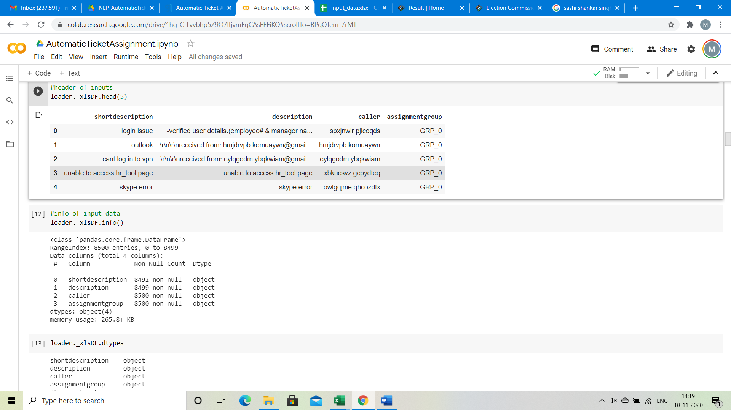

Column 1- shortdescription: A short description of the incident which has been raised

Column 2- description: A detailed description of the incident which has been raised

Column 3- caller: This is the caller id

Column 4- assignmentgroup: This the incident resolution group to which the ticket has been assigned

Further information of the given input data is given below:

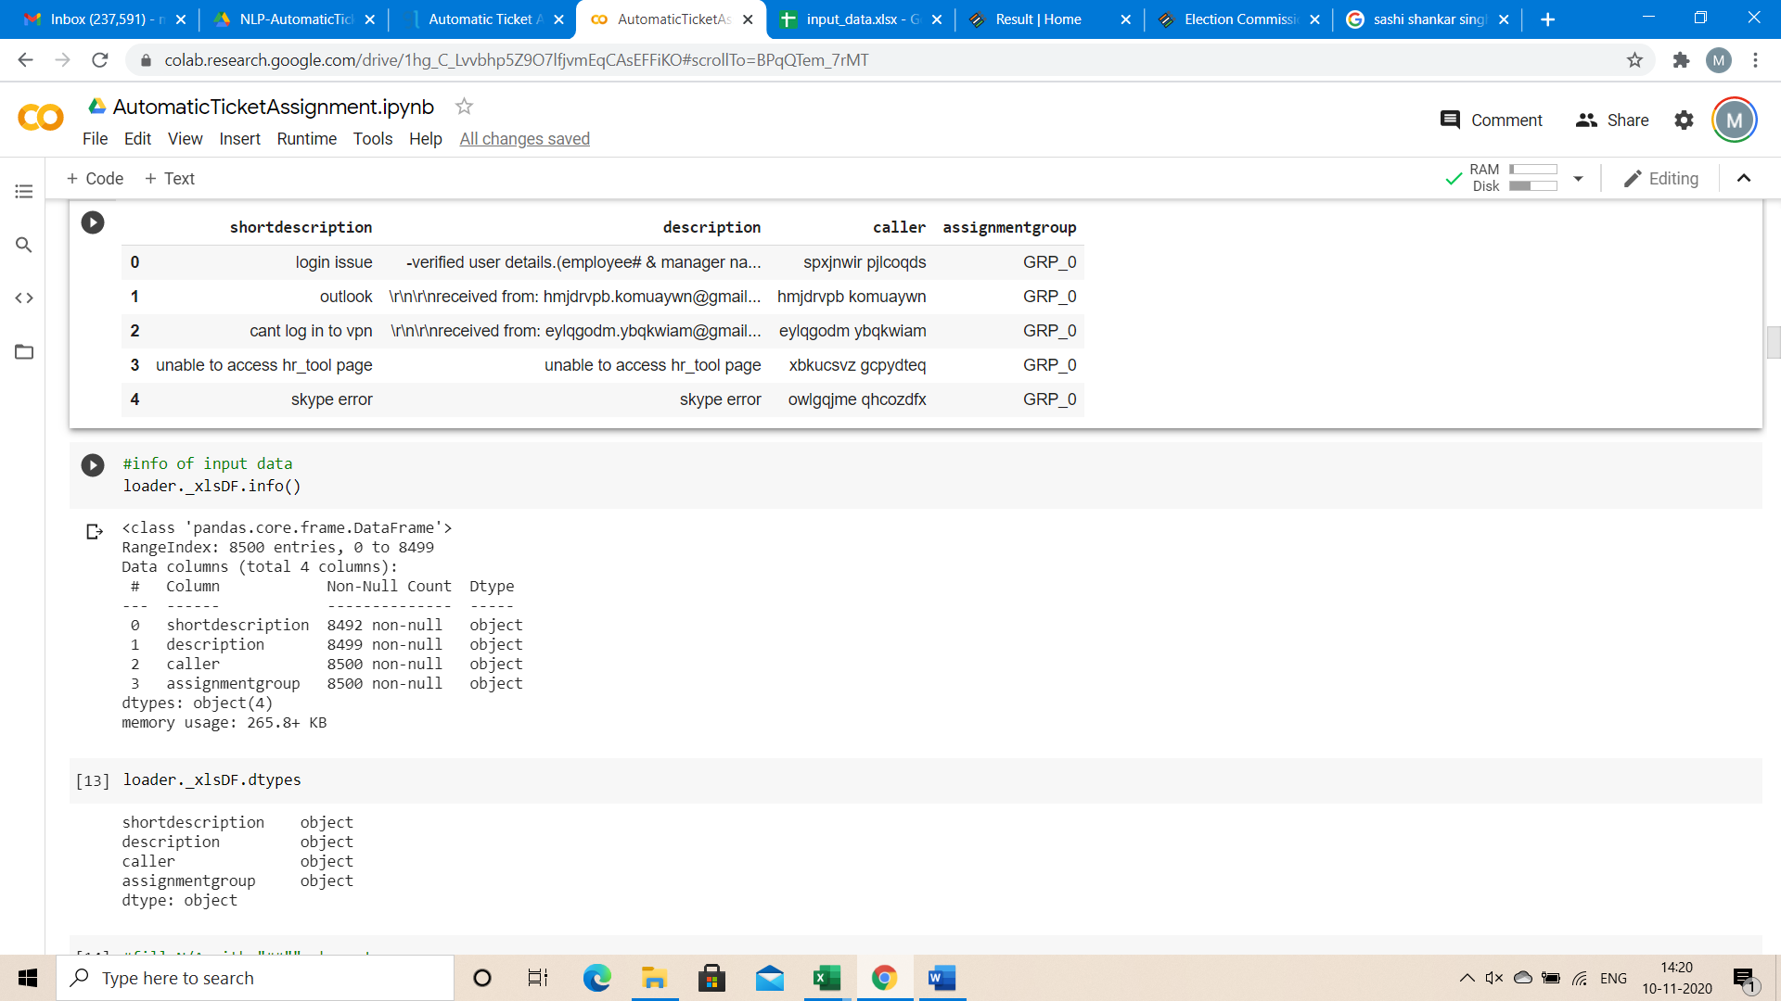

The data contains 8500 entries, with some missing values in certain columns.

As the data is significantly imbalanced………..following technique was used to pre-process the data.

Subsequently word2vec embeddings are used which are then used as the input to a LSTM model to get the final results. To optimise parameters, grid search and random search techniques were also used. The final accuracy was xx%

2.Summary of the ApproachtoEDA and Pre-processing

Include any insightful visualization you have teased out of the data. If you’ve identified particularly meaningful features, interactions or summary data, share them and explain what you noticed. Visual displays are powerful when used well, so think carefully about what information the display conveys.

3.Deciding Models and Model Building

Based on the nature of the problem, decide what algorithms will be suitable and why?Experiment with different algorithms and get the performance of each algorithm.

4.How to improve your model performance?

What are the approaches you can take to improve your model? Can you do some feature selection, data manipulation and model improvements